ECO3702: Advanced Macroeconomics Lecture Note 2.
2018
Modification of IS – LM Model with Endogenous Money

Kaan Öğüt

Bahçeşehirunıversıty

- Modification of IS – LM Model with Endogenous Money
  - Endogenous Money Supply and Exogenous Interest Rate
    - Endogenous Money Multiplier
    - Credit Money and Endogenous Money Supply
    - Exogeneity of Interest Rate
  - Interest Rate Pass Through Mechanism
  - Saving - Investment Imbalance
  - Consumption, Investment and Credit

- Modification of IS – LM Model with Endogenous Money
  - Endogenous Money Supply and Exogenous Interest Rate

2.1.1. Endogenous Money Multiplier
Palley (2013) described the money multipler as a positive function of bonds (market) or deposits interest rates like Mishkin we mentioned about it in the first lecture note . Money multiplier increases in response to higher interest rates that is the oppotunity cost of holding money. Palley (2013) also add a random shock parameter in multiplier with interest rate to represents expectations.
Similar to Palley (2013), we will relate the monetary multiplier to interest rate. Under the assumption that savings are mostly deposited as time deposits and interest is not paid to checking deposits, the endogenous money has some important consequences on the economy. Also changes in agents’ portfolio preferences regarding holding cash, demand deposits and time deposits cause canges in money multiplier. It is called “money multiplier portfolio endogeneity” by Palley (2007).
Some variables (c and t) of the multipliers are determined by households and firms; and the other one (e) is determined by banking sector. Therefore, it is now time to leave our temporary assumption of these variables and monetary multiplier being constant.
$c=\frac{CU}{D^{C}}$ is currency ratio set by privates:
$e=\frac{ER}{D^{C}}$ is excess reserve ratio set by banks
$t=\frac{D^{T}}{D^{C}}$ is time deposits ratio to checkable deposits set by privates
$rr=\frac{RR}{D^{C}}$is required reserve ratio is set by central bank
Money multiplier for $M2$;
The first analysis that considers money supply endogenous is based on the monetary multiplier. According to money multiplier for $M2$;
$$MB=CU+rr\left(D^{C}+tD^{C}\right)+eD^{C} =D^{C}\left(c+rr\left(1+t\right)+e\right) (1a)$$
$$M2=CU+D^{C}+D^{T}=\left(c+1+t\right)D^{C} (1b)$$
$$M^{S}=M2=μ_{2}MB$$
$$μ_{2}=\frac{\left(c+1+t\right)}{c+rr\left(1+t\right)+e} (1c)$$

$$MB=cD^{C}+{rr}^{C}D^{C}+{rr}^{T}tD^{C}+eD^{C} =D^{C}\left(c+{rr}^{C}+t*{rr}^{T}+e\right) (2a)$$
$$μ_{2}=\frac{\left(c+1+t\right)}{c+{rr}^{C}+t*{rr}^{T}+e} (2c)$$
To make it simple it can be defined as follows.
$$μ_{2}=\frac{1+c+t}{rr+e+c} (3c)$$

Uygulamada TCMB’nin belirlediği vadesiz ve 3 aylığa kadar vadeli mevduatlar için zorunlu karşılık oranları %11, 6 aya kadar, 1 yıla kadar ve 1 yıldan uzun vadeli mevduatlar için ise sırasıyla %8, %6 ve %4,5’tur.
Weighted Average Reserve Requirement Ratio in terms of Foreign Currencies

Weighted Average Reserve Requirement Ratio in terms of TL

    - Credit Money and Endogenous Money Supply
Money demand function includes consumption and investment directly. If spending is financed by credits then money supply will be related to consumption and investment, as well. Therefore, both money supply and money demand are functions of consumption and investment spending. In this case, a change in money demand resulting from a change in spending, money supply also changes in the same direction. This means that the adjustment that must occur as a result of a change in the price (interest rate) diminishes. Quantitative adjustment of money supply follows the money demand directly and it makes the interest rate more stable (Palley, 2001).
Considering that investment decisions and consumption are mostly financed by credits and moreover demand for credit increases money supply in our financialised recent economic system. Money supply is related to borrowing.
When firms and households demand credits from the banking sector in order to finance their expenditures, banking sector accommodates (provides) their credit demand. Therefore, credit supply is an automatic response to the credit demand of the firms and households and there is no excess money supply in this framework (Moore, 1986; 1988). Since expenditure of someone is others revenue, credits also increase the level of deposits in the system (Sawyer, 2001).
Equation 26 can be reconsidered as an endogeneity of money supply and central bank credit $L^{CB}$is determined by banking sector to provide the private sector loan demand.
The main business of banks is making and selling loans. Because of this they do not prefer increase loan interest rates in short run. Instead of it they try to provide loan demands of privates.
The central bank is the lender of the last resort and it is responsible for providing liquidity to the monetary system at discount rate (Hein, 2008 :43).
$$\underset{assets}{\underbrace{L^{S}+B^{B}+RR+ER}}=\underset{liabilities}{\underbrace{D+L^{CB}}}$$
$$L^{S}=D+L^{CB}-\left(B^{B}+RR+ER\right)$$
$$L^{D}=L^{S}$$
$L^{D}=L^{S}$ would mean loan supply is determined by loan demand
$$L^{D}=\underset{↑}{\underbrace{D+L^{CB}}}-\left(\underset{↓}{\underbrace{B^{B}+RR+ER}}\right)$$
$$L^{CB}=L^{D}-D+RR+ER+B^{B}$$
$L^{CB}$ is partially determined endogenously, by loan demand $L^{D}$ and deposits $D$ set by households and firms also amount of excess reserves $ER$ depends on decision of the banks, on the other hand level of $rr$ is decided by CB and also according to our assumption amount of bonds $B^{B}$ automatically respond to open market operations of the CB. Money supply can be demonstrated in terms of assets of CB like in equation 28
$$M^{S}=μ_{2}\left(L^{CB}+B^{CB}\right)$$
Definition of money supply can be rewritten.
It is supposed that $B^{B}+B^{CB}=constant$
$$M^{S}=μ_{2}\left(\underset{MB}{\underbrace{\overset{L^{CB}}{\overbrace{L^{D}-D+RR+ER+B^{B}}}+B^{CB}}}\right)$$

Although most of the components of money supply are determined endogenously by households, firms and banking sector, central bank can partially manage the money supply through the reserve requirement ratio $rr$ and open market operations $B^{CB}$. Nonetheless latter does not affect the money supply because of $B^{B}+B^{CB}=constant$.
$$M^{S}=\frac{1+c+t}{rr+e+c}\left(L^{D}-D+RR+ER+\underset{constant}{\underbrace{B^{B}+B^{CB}}}\right)$$
$$M^{S}=\frac{1+c+t}{rr+e+c}\left(L^{D}-\left(1-rr\right)D+ER+\underset{constant}{\underbrace{B^{B}+B^{CB}}}\right)$$
In normal conditions it is expected that excess reserves of banking sector are very small and $rr$ is set by CB hence it can be claimed that the main determinant of money supply is the difference of the credits and the deposits.

Implementation of expansionary monetary, through the OMO:
$$M^{S}=μ_{2}\left(L^{D}-D+RR+ER↑+\underset{constant}{\underbrace{B^{B}↓+B^{CB}↑}}\right)$$
    - Exogeneity of Interest Rate
Since money supply is endogenous, money market needs an exogenous variable. Interest rate is the most suitable candidate for this post. But in an economic system there are so many interest rates which interacts with the decisions made by households, firms and banking sector, i.e., they both affect the consumption - saving and investment decision of these agents and they are affected from these decisions as well. Therefore, the first problem is to decide which interest rate must be chosen. The policy interest rate - which is determined exogenously by the central bank - seems to be the most suitable interest rate to be regarded as the policy variable. However, if the central bank uses this interest rate in order to affect the endogenous variables such as inflation, unemployment rate or output level, then this rate is also affected by these variables. In this case, policy interest rate is not an exogenous variable but a reaction function and it would be flawed to assume that policy interest rate is completely exogenous.
Wray (2006: 271-72), classifies exogenous variables as strong and weak. Strongly exogenous variables are those which independent of all the actual and future values of endogenous variables of the model. On the other hand, weakly exogenous variables are independent of the actual values of endogenous variables but they may depend on the future or expected values of them.
Since central banks use reaction functions depend on the past, actual and expected values of the endogenous variables such as inflation, then policy interest rate can be a weakly endogenous variable at its best.
Moreover, although policy interest rate is determined by the monetary authority to affects bond, deposit and loan interest rates; depending on the market conditions, interest rates in the money market may be different from this policy interest rate. In this study, according to the loanable funds theory, credit interest rate is assumed to be determined by the credit demand and the average cost of the loanable funds.
Romer (2000) argued that FED uses federal funds rate as a policy variable for achieving inflation and output targets and monetary aggregates play a very limited role. Monetary authorities prefer to control the interest rate instead of the level of money supply.
For the last three decades, since the failure of the monetarist experiments in the early 1980s, central banks have explicitly targeted nominal interest rates. Nominal interest rate targeting transforms the representation of the money market in the conventional money multiplier model, as shown in following figure. Now, the money supply schedule is horizontal at the target interest rate. The logic is the monetary authority supplies or draws down liquidity to keep the interest rate at the target.
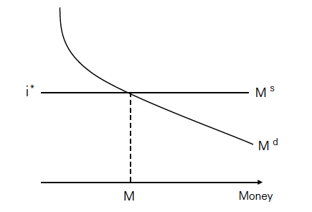

In this new tradition of models based on the Romer's framework, a Taylor rule equation for monetary policy function and an expectations-augmented Phillips curve equation for infation adjustment function are used (Hsing, 2005; Clark and Hsing, 2005). By far the most used framework for modeling the monetary policy in the recent years, Taylor rule played an important role as constituing a foundation for the new consensus (Arestis, 2009).
Taylor Rule is formulated as in next equation
$$i^{P}=r+π^{e}+δ_{1}\left(π-\overline{π}\right)+δ_{2}\left(\frac{Y-\overline{Y}}{\overline{Y}}\right)$$
Policy rate $i^{P}$ in equation this is the cost of the using central bank credits $L^{CB}$. It can be considered as even if CB has to provide the credit demand comes from banking sector, it can increase the unit cost of using credit.

Policy Interest Rate
The policy interest rate is an interest rate that the monetary authority (i.e. the central bank) sets in order to influence the evolution of the main monetary variables in the economy (e.g. consumer prices, exchange rate or credit expansion, among others). The policy interest rate determines the levels of the rest of the interest rates in the economy, since it is the price at which private agents-mostly private banks-obtain money from the central bank. These banks will then offer financial products to their clients at an interest rate that is normally based on the policy rate.
Different countries have different policy interest rates. The most common are the overnight lending rate, discount rate and repurchase rate (of different maturities). Normally, central banks use the policy interest rate to perform contractive or expansive monetary policy. A rise in interest rates is commonly used to curb inflation, currency depreciation, excessive credit growth or capital outflows. On the contrary, by cutting interest rates, a central bank might be seeking to boost economic activity by fostering credit expansion or currency depreciation in order to gain competitiveness.

Although, in the past, central banks thought of the money supply as the monetary policy variable, they now focus directly on the interest rate. They choose an interest rate, call it $i^{P}$ and adjust the money supply so as to achieve it.
As you remember Blanchard shall think of the central bank as choosing the interest rate (and doing what it needs to do with the money supply to achieve this interes rate). This will make for an extremely simple LM curve, namely, a horizontal line.

  - Interest Rate Pass Through Mechanism
After stating that the policy interest rate is determined by equation 30, it is required to define at least three more interest rates: Loan, deposit and bonds. The last is usually regarded as the money market interest rate. Generally it is accepted that loan rate is determined by banking sector with a mark-up coefficient over the policy (or money market rate) that is set by central bank (Palley, 2013:11).
$$i^{L}=\left(1+μ\left(ρ\right)\right)i^{P}$$
$$i^{L}=\left(1+μ\left(ρ\left[L^{D}\right]\right)\right)i^{P}$$
Pollin (2008: 5-7) argues that it would be an incomplete picture of the market interest rate, if it is computed as adding a constant markup on the policy interest rate. The commercial banks’ mark-up on the base rate is determined by their risk and liquidity considerations, and also by the degree of competition on the banking sector. Bank can rise up the mark-up as lending increases. It may be due to increased default risk of repayment resulting from borrower quality deterioration as the volume of lending increases (Palley, 2013:13). So mark-up coefficient can be perceived as a variable instead of a constant.

The controlling power of the monetary authority on the market interest rates is very limited and these rates are determined endogenously as a result of the financial operations. It is implied that although the policy rate can be considered as a (partially) exogenous variable, loan rate cannot be derived exogenously. Given the imperfect information lending could be restricted by banks’ willingness to lend for fear of defaults and loan rates would also be altered so as to reflect cost associated with default (Palley 2001, 17, 21, 22).
$$i^{L}>i^{P}≈i^{D}$$

An increase in credit demand may result in an increase in the deposit interest rates, besides its effect on credit interest rates. There are so few papers in the literature on the determination of the deposit rates. Generally, it is assumed that it would be close to the policy interest rate, as in equation when the $ε$ represents normally distributed error term.
$$i^{D}=i^{P}+ε$$
Since deposits are another source of credits, as central bank loans, it is plausible to think that these two would be close to each other and move together.
If the CB’s sources and deposits are considered as perfect substitutes, relation between them can be described as follows.
$$i^{D}=\left(1-rr\right)i^{P}$$

Market Interest Rate in Turkey:
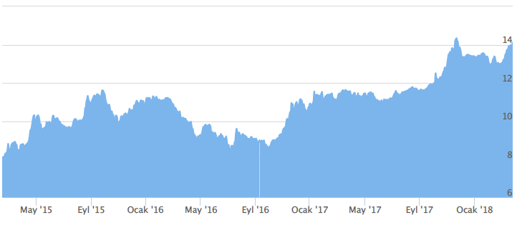
However, we should not forget that these two credit sources are not perfect substitutes. Although the terms of deposits are usually shorter than that of the loans, the terms of the central bank loans are shorter. Therefore, meeting the credit demand with central bank loans would increase the overall risk of banking sector. Hence, banking sector would increase the deposit interest rates in order to attract more deposits. But the existence of alternative saving instruments is important at this point. If deposit rates are assumed to be determined by the policy interest rates, then it can be stated for loan rate, and it is more realistic.
$$i^{L}=\left[i^{D}\left(1-\frac{L^{CB}}{L^{D}}\right)+\left(i^{P}+σ\right)\frac{L^{CB}}{L^{D}}\right]+i^{D}rr\frac{D}{L^{D}}$$
Expected assets and expected liabilities of the banking sector belongs to end of the period can be described as in equations.
In order to simplicity it is assumed that $B^{B}=0 and ER=0$ so
$$L^{CB}=L^{D}-D+\underset{rrD}{\underbrace{RR}}+\underset{0}{\underbrace{ER+B^{B}}}$$
$$L^{CB}+D=L^{D}+rrD$$
$$rrD+L^{D}=L^{CB}+D$$
$$rrD+\left(1+i^{L}\right)L^{D}=\left(1+i^{D}\right)D+\left(1+i^{P}\right)L^{CB}$$
$$L^{CB}+D=L^{D}+rrD$$
$$L^{CB}=L^{D}-\left(1-rr\right)D$$
$$i^{L}L^{D}=D+i^{D}D+L^{CB}+i^{P}L^{CB}-rrD-L^{D}$$
$$i^{L}L^{D}=i^{D}D+L^{CB}+i^{P}L^{CB}+\underset{-L^{CB}}{\underbrace{D-rrD-L^{D}}}$$
$$i^{L}L^{D}=i^{D}D+i^{P}L^{CB}$$
$$i^{L}=i^{D}\frac{D}{L^{D}}+i^{P}\frac{L^{CB}}{L^{D}}$$
$L^{CB}=L^{D}-\left(1-rr\right)D → D=L^{D}-L^{CB}+rrD$
$$i^{L}=i^{D}\frac{L^{D}-L^{CB}+rrD }{L^{D}}+i^{P}\frac{L^{CB}}{L^{D}}$$
$$i^{L}=i^{D}\left(1-\frac{L^{CB} }{L^{D}}\right)+\left(i^{P}+σ\right)\frac{L^{CB}}{L^{D}}+i^{D}rr\frac{D}{L^{D}}$$
This is the minimum loan interest rate which is determined by cost of the making loan.
$$L^{D}=L^{S}$$
$$i_{min}^{L}=\left[i^{D}\left(1-\frac{L^{CB}}{L^{S}}\right)+\left(i^{P}+σ\right)\frac{L^{CB}}{L^{S}}\right]+i^{D}rr\frac{D}{L^{S}} and i^{L}=\left(1+μ\left(L^{D}\left[ρ\right]\right)\right)i_{min}^{L}$$
We may also expand loan interest rate:
$$i_{min}^{L}=i^{D}\left(1-\frac{L^{CB}}{L^{S}}\right)+\left(i^{P}+σ\right)\frac{L^{CB}}{L^{S}}+\left(i^{D}-i^{B}\right)\frac{{ B}^{B}}{L^{S}}+i^{D}\left(rr+e\right)\frac{D}{L^{S}}$$
$$i^{L}=\left(1+μ\left(L^{D}\left[ρ\right]\right)\right)i_{min}^{L}$$

Since the main component of the profits of banking sector is the spread between loan and deposit rates, they will always try to keep this spread as much as possible.
Central bank may not always accommodate rising bank loans with the required amount of central bank money at a given rate of interest therefore commercial banks may be forced to attract reserves from the public (Hein, 2008 :47) If central banks do not give the credit that banking sector demands, this could be regarded as a form of credit rationing. But this is not desirable for central banks because it would raise the doubts about its role of lender of last resort. Instead, the central bank can implement an interest rate corridor system and can create additional uncertainty for the banking sector.

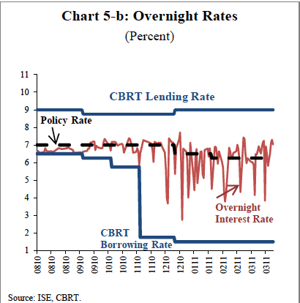
Corridor System:
On the other hand, central banks can use interest rate corridor in order to increase the effectiveness of required reserves. But using the interest rate corridor reduces the ability of policy rate to determine the market interest rate.

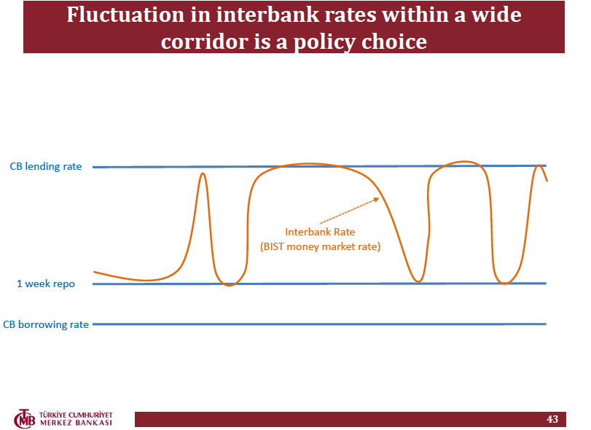
$i^{WAC}$: Weighted Average Cost of the CBRT Funding. $α_{1}+α_{2}=1$
$$i^{WAC}=α_{1}i^{P}+α_{2}\overline{i}=i^{P}+σ$$
$$σ=α_{2}\overline{i}-\left(1-α_{1}\right)i^{P}$$
$$σ=α_{2}\overline{i}-α_{2}i^{P}=α_{2}\left(\overline{i}-i^{P}\right)$$
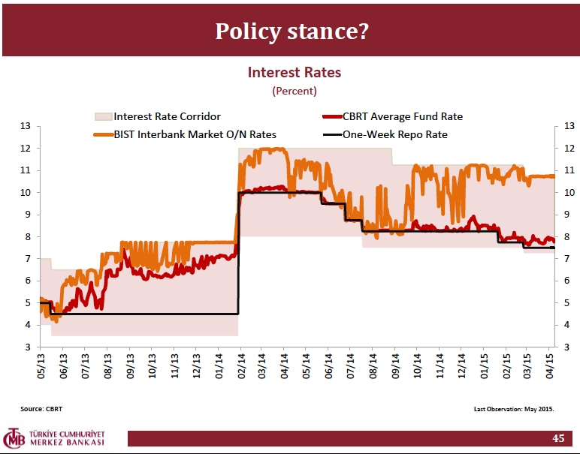
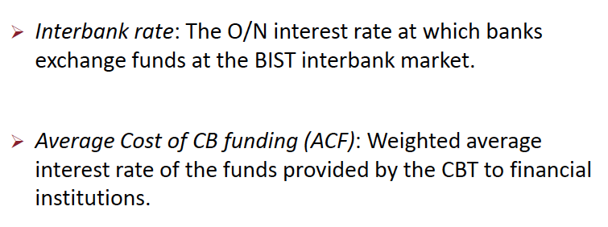
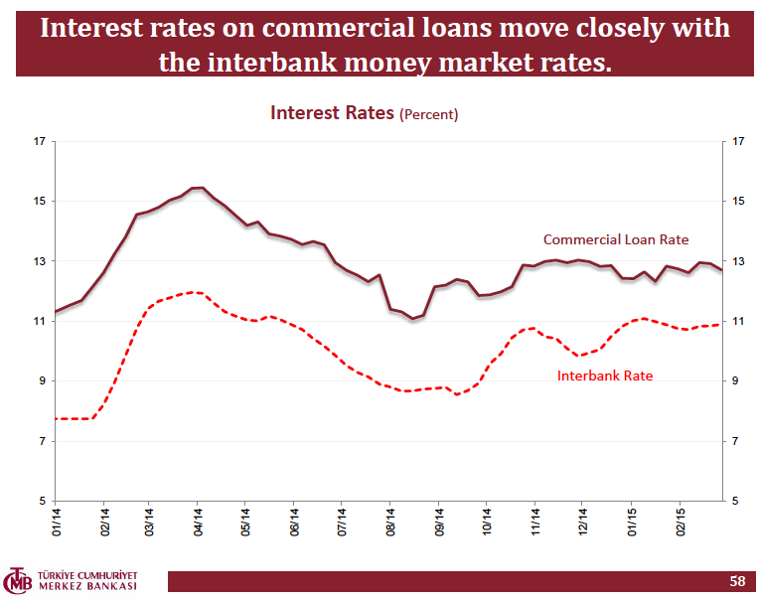
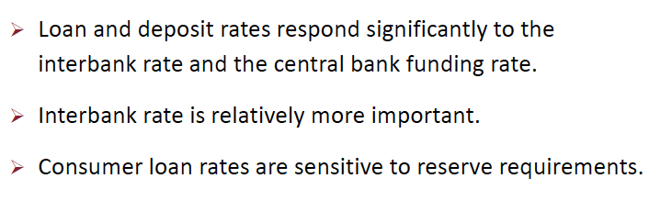
O/N Lending Interest Rate - One-Week Repo Rate

O/N Lending Interest Rate - One-Week Repo Rate - CBRT Average Fund Rate

O/N Lending Interest Rate - One-Week Repo Rate - CBRT Average Fund Rate - BIST Overnight Repo Rates

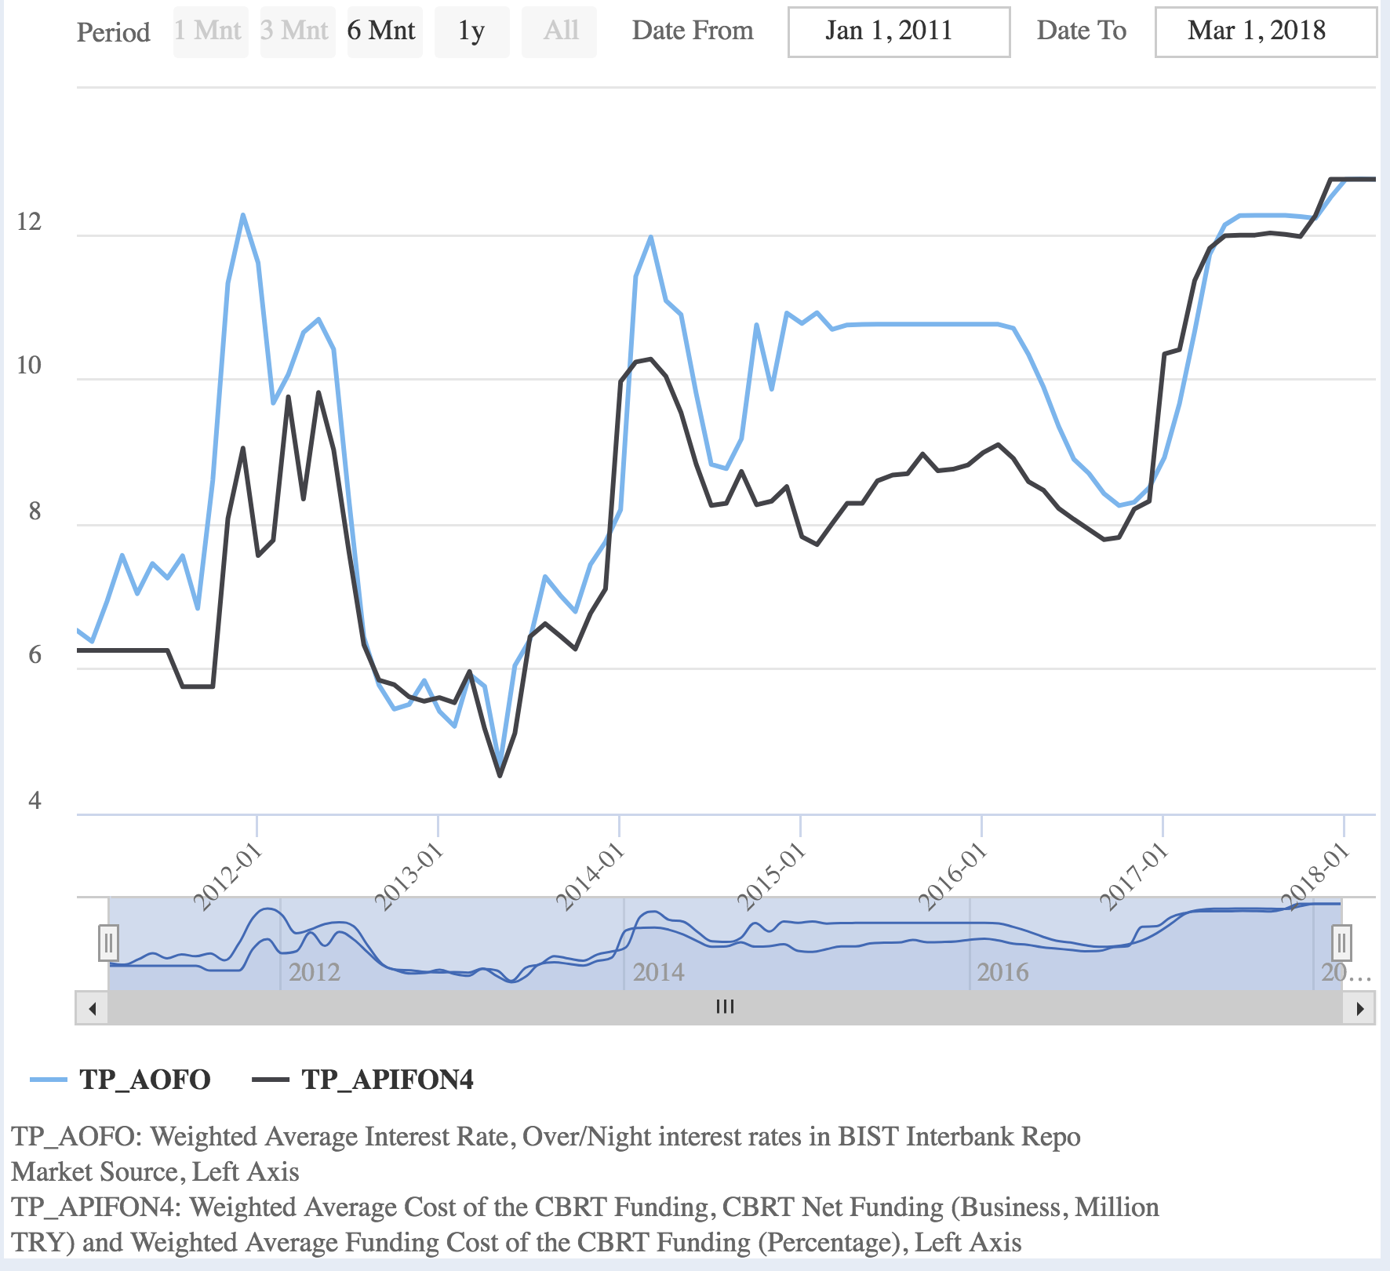

Therefore, loan and deposit interest rates equations may be revised. In this case, we write a profit function for the banking sector and try to find the two interest rate levels (loan and deposit) that maximizes this function:
$$Π=\left({1+i}^{L}\right)L^{S}\left(i^{L}\right)+rrD\left(i^{D}\right)+\left(1+i^{B}\right)B\left(i^{B}\right)-\left(1+i^{D}\right)D\left(i^{D}\right)-\left({1+i}^{P}+σ\right)\left[L^{S}\left(i^{L}\right)-\left(1-rr\right)D\left(i^{D}\right)\right]$$
$$i^{L}=\frac{i^{P}+σ}{1-\frac{1}{\left|E_{L,i^{L}}\right|}}$$
$$i^{D}=\frac{\left(i^{P}+σ\right)\left(1-rr\right)}{1+\frac{1}{E_{D,i^{D}}}}$$
$$Π=\left({1+i}^{L}\right)L^{S}\left(i^{L}\right)+rrD\left(i^{D}\right)+B\left(1+i^{B}\right)-\left(1+i^{D}\right)D\left(i^{D}\right)-\left({1+i}^{P}+σ\right)\left[L^{S}\left(i^{L}\right)-\left(1-rr\right)D\left(i^{D}\right)\right]$$
$$\frac{∂Π}{∂i^{D}}= rr\frac{dD}{di^{D}}-\left[D+\left(1+i^{D}\right)\frac{dD}{di^{D}}\right]+\left({1+i}^{P}+σ\right)\left(1-rr\right)\frac{dD}{di^{D}}=0$$
$$rr-\left[D\frac{di^{D}}{dD}+\left(1+i^{D}\right)\right]+\left({1+i}^{P}+σ\right)\left(1-rr\right)$$
$$rr-\left[D\frac{di^{D}}{dD}+\left(1+i^{D}\right)\right]+{1+i}^{P}+σ-rr-rri^{P}-rrσ$$
$$-D\frac{di^{D}}{dD}-i^{D}{+i}^{P}+σ-rri^{P}-rrσ$$
$$i^{P}+σ-rri^{P}-rrσ=D\frac{di^{D}}{dD}+i^{D}$$
$$\left(i^{P}+σ\right)\left(1-rr\right)=D\frac{di^{D}}{dD}+i^{D}$$
$$\frac{\left(i^{P}+σ\right)\left(1-rr\right)}{i^{D}}=\frac{D}{i^{D}}\frac{di^{D}}{dD}+1$$
$$\frac{\left(i^{P}+σ\right)\left(1-rr\right)}{i^{D}}=\frac{1}{E_{D,i^{D}}}+1$$
$$i^{D}=\frac{\left(i^{P}+σ\right)\left(1-rr\right)}{\frac{1}{E_{D,i^{D}}}+1}$$

$$Π=\left({1+i}^{L}\right)L^{S}\left(i^{L}\right)+rrD\left(i^{D}\right)+B\left(1+i^{B}\right)-\left(1+i^{D}\right)D\left(i^{D}\right)-\left({1+i}^{P}+σ\right)\left[L^{S}\left(i^{L}\right)-\left(1-rr\right)D\left(i^{D}\right)\right]$$
$$\frac{∂Π}{∂i^{L}}=L^{S}+\left({1+i}^{L}\right)\frac{dL^{S}}{di^{L}}-\left({1+i}^{P}+σ\right)\frac{dL^{S}}{di^{L}}=0$$
$$L^{S}+\left({1+i}^{L}\right)\frac{dL^{S}}{di^{L}}=\left({1+i}^{P}+σ\right)\frac{dL^{S}}{di^{L}}$$
$$L^{S}\frac{di^{L}}{dL^{S}}+\left({1+i}^{L}\right)=\left({1+i}^{P}+σ\right)$$
$$L^{S}\frac{di^{L}}{dL^{S}}{+i}^{L}=i^{P}+σ$$
$$\underset{\frac{1}{E_{L,i^{L}}}}{\underbrace{\frac{L^{S}}{i^{L}}\frac{di^{L}}{dL^{S}}}}+1=\frac{i^{P}+σ}{i^{L}}$$
$$i^{L}=\frac{i^{P}+σ}{1-\frac{1}{\left|E_{L,i^{L}}\right|}}$$
In order not to ration the credit demand of the banking sector, central bank determines the lower and upper bound of the interest rate corridor between the policy rate and creates uncertainty in order to influence credit demand. Of course central bank can also prefer to change just one bound of the corridor for this aim. Since this study aims to analyze a small-closed economy, and the lower bound of the corridor is generally used for influencing the foreign capital movements, we will concentrate on the upper bound of the interest rate $\overline{i}$ corridor.
The weighted average of the policy interest rate and the upper bound of the interest rate corridor determine the average funding rate of banking sector, and the weight is controlled directly by the central bank and it can be express with policy interest rate and uncertainty parameter $σ$.
The spread between the policy rate and the upper bound of the corridor can be regarded as an uncertainty parameter and it will be effective on the demand of banking sector for the central bank loans. Banks adjust their administered lending and deposit rates response change in policy rate. Short term market wholesale rates adjust to maintain the required risk and maturity differentials (Moore, 2006: 252).
In this study, bond is regarded as just an alternative wealth factor and an asset with which central bank carries out its open market operations. Therefore, bond market interest rate which is assumed to be the market interest rate moves together with the policy interest rate.

  - Saving - Investment Imbalance
In the macroeconomics textbooks, national income consists of consumption, investment and government expenditures, in a closed economy. Following the approach of Keen (2011), by the addition of the changes in the stock variables such as wealth and debt besides the flow variables such as consumption and investment, a national income equation can be built in a dynamic framework. This framework allows us to model consumption and investment expenditures financed by borrowing. In this context, similar to Keen’s (2011) approach, total of aggregate demand and change in wealth equals to the total of income and change in debt stock. Since household and firm borrowing is realized through credits, credit stock will be used instead of debt stock.
$$Y+\frac{dL^{D}}{dt}=C+I+G+\frac{dW}{dt} \left(37\right)$$
In fact, none of the components of aggregate demand is constrained with income. Agents may have liquid assets they saved before and/or they can finance their expenditures by borrowing from banks. This process both creates money and increase employment through its effects on demand, which indicates the endogeneity of money (Davidson, John Maynard Keynes, 2009, s. 89)
In his A Treatise on Money study, Keynes suggests that savings and investment expenditures are done by different people for different reasons in modern societies, and in an economy based on the credit money, interest rate does not serve as an automatic mechanism that would these two quantities (Skousen, 1992: 91). Moreover, in his “How far are Bankers Responsible for the Altrernations of Crisis and Depression” study in 1913, he emphasized that banks could lend entrepreneurs more than the deposits they hold, and this credit creation can be the source of inflation (Skidelsky, 2010: 60). In this sense, savings and investments can be different from each other, it is not necessary that each saving action will turn into an investment (Skidelsky, 1994: 218,315).
According to Keynes (1930: 136), the sharing of output between investment and consumption is not needed to be the same as the sharing of income between saving and consumption.
If the natural interest rate is defined as that equates investment to savings, the deviation of interest rate that is determined by banking sector from the natural rate would result in an excess demand or excess investment. The general approach of the banking sector is expanding the credits and this may cause excess investments. According to Tamborini (2008), Keynes tries to expain the unemployment equilibrium with savings and investment inconsistency.
In accordance with this equation, a relationship between savings and investments can be rederived as follows.
$$S+\frac{dL^{D}}{dt}=I+\frac{dW}{dt}$$
Our previous assumption about balance budget requires that saving, borrowing, wealth accumulating and investment are done by private sector.
As it is seen, even if economy is close, savings and investments are not necessarily equal to each other. We can express the equation 38 with the net change in wealth.
$$S=I+\left(\frac{dW}{dt}-\frac{dL^{D}}{dt}\right)$$
Investments and wealth acquisition is financed with savings and borrowing. Thus, an equation in which the change of stock variables and flow variables are used together is derived different from the classical IS-LM or AD-AS approach. That kind of stock – flow consistent model was developed by Godley and Lavoie (2007, s. 7). Thus flow variables and change in stock variables are taken to analyze their interactions.
Therefore, the total money stock in the economy is equal to the sum of the quantitiy of money at the beginning of the period and money created within the period as a result of credit expansion in the banking sector. And this change in borrowing also influences aggregate demand (Keen, 2014). As Keen (2014) said rate of change of money is equal the rate of change of debt.
$$\frac{dM}{dt}=\frac{dL^{D}}{dt}$$
Under the assumptions of total reserves of banking sectors remain constant like government debt stock, we may get equation.
$$\frac{dM}{dt}=μ_{2}\left(\frac{dL^{D}}{dt}-\frac{dD}{dt}\right)+\frac{dμ_{2}}{dt}\left(L^{D}-D\right)$$

  - Consumption, Investment and Credit
For simplification, it is assumed that household’s wealth accumulation through savings is realized through bank deposits and stocks. Therefore, wealth is equal to the sum of deposits and stocks. Blanchard (1981), in his pioneering study in which he elaborated stock markets and interest rate interaction, he assumed that stock market and short-term bond markets are perfect substitutes (Shone, 2002, 456). Similar to this, in this study, we have also assumed that financial assets include bonds, deposits and stocks. Because of deposits contain both type of them (checkable and saving deposists) we have ignored currencies.
$$W=B^{G}+D+qQ$$
It can also be described with money.
$$W=B^{G}+\underset{M}{\underbrace{D+CU}}+qQ$$
We assumed that households are the owner of the assets except bonds.
$$W^{H}=D+qQ$$
Net household wealth is determined by the difference between the sum of deposits and value of stocks and credit stock.
$$NW=D+qQ-L^{D}$$
Although these assets are not perfect substitutes, there is a substitution between them. Households determine their demand for financial assets by comparing expectations of stock returns with deposit interest rates. Change in wealth can be described as follows
$$\frac{dW}{dt}=\underset{0}{\underbrace{\frac{{dB}^{G}}{dt}}}+\frac{d\left(D^{C}+D^{T}\right)}{dt}+D^{T}i^{D}+\frac{dq}{dt}Q+q\frac{dQ}{dt}$$
Change in household wealth
$$\frac{dW^{H}}{dt}=\frac{d\left(D^{C}+D^{T}\right)}{dt}+D^{T}i^{D}+\frac{dq}{dt}Q+q\frac{dQ}{dt}$$
In order to reflect typical consumer behavior better, it is assumed that households make their credit payments from their disposable income and until they do not fall in financial distress, they do not consider use their assets for credit repayments. When $n$ is an average maturity of consumer credits, disposable income is defined as monthly.
$$Y^{d}=Y-T-\frac{L^{D}{\left(1+i^{L}\right)}^{n}}{12n}$$
Credits increase the consumption of households in each term, but also they constitute the total liabilities of the consumer. As the liabilities increase, households total net value decreases.
Disposable income can be saved or consumed by individuals and saving can be described like in next equation
$$S=\frac{dD}{dt}+q\frac{dQ}{dt}$$
In the model, change in deposits and stocks are defined as functions of disposable income, deposit interest rates and expected prices of stock market. Change in stock prices is described with its demand.
$$\frac{dD}{dt}=\dot{D}\left(\underset{+}{\underbrace{Y^{d}}},\underset{+}{\underbrace{i^{D}}},\underset{-}{\underbrace{{\dot{q}}^{e}}}\right))$$
$$\frac{dQ}{dt}=\dot{Q}\left(\underset{+}{\underbrace{Y^{d}}},\underset{-}{\underbrace{i^{D}}},\underset{+}{\underbrace{{\dot{q}}^{e}}}\right)$$
$$\frac{dq}{dt}=\dot{q}\left(\frac{dQ}{dt}\right)$$
Consumer credit demand is dependent on net wealth, besides interest rate. Therefore, the contractionary effect of debt accumulation on credit demand can be elaborated in this way.
$$\frac{dL^{Dd}}{dt}={\dot{L}}^{Dd}\left(NW,i^{L}\right)$$
Credit stock, namely debt stock $L^{D}$changes with and amount equal to the difference between new credits and credit payments.
$$\frac{dL^{D}}{dt}=\frac{dL^{Dd}}{dt}-\frac{L^{D}{\left(1+i^{L}\right)}^{n}}{12n}$$
Therefore, while credits constitute a positive feedback loop on the consumption and income, credit payments constitute a negative feedback loop over consumption. Consumption is a function of disposable income, saving and new consumer credits.
$$C=Y-T-\frac{L^{DH}{\left(1+i^{L}\right)}^{n}}{12n}-\left(\frac{dD}{dt}+q\frac{dQ}{dt}\right)+\frac{dL^{DdH}}{dt}$$
Consumption function is dependent indirectly both on deposit interest rate and credit interest rate. Consumers consider deposit interest rate when making saving decisions, on the other hand they consider credit interest rate when determining their credit demands.
Finally investments are assumed to be determined by the consumption in the previous term and, as it is in Samuelson’s (1939) multiplier-accelerator model, it changes linearly with changes in consumption. Thus, it is assumed that investments adjust to changes in consumption with time.
$$I=θ\frac{dC}{dt} (53)$$
Similar to the Bernanke and Blinder’s (1988) study it is supposed that investments are financed with bank credits.

